DPA Holds Its Annual General Meeting-2022:
The Annual General Meeting of Delhi Printers' Association was held at Malviya Smriti Bhawan on April 23, 2022.
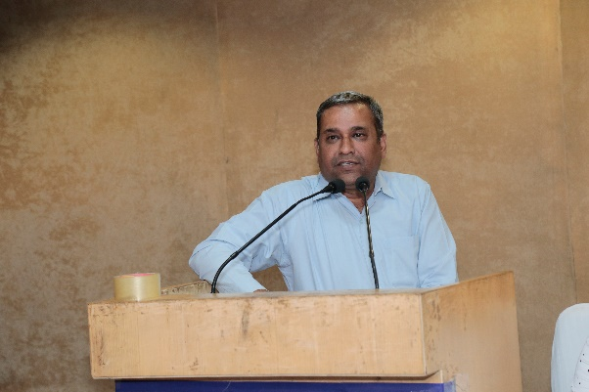
Welcoming the members to the AGM President Mr. Sunil Jain expressed his gratitude to them for reposing their faith in him by giving him another term as President for the year 2021-2022 and also for extending their full cooperation and support. He stated that due to the havoc played by the Covid-19 pandemic Delhi Printers' Association could not hold some of its events during the outgoing year. He told that while details of the association's activities during the period of April 1, 2021 to March 31, 2022 are being presented by the Hon. General Secretary in his Annual Report, DPA had also participated in the first formal meeting organised by Haryana State Industrial and Infrastructural Corporation wherein an opportunity to acquire land for a cluster of printing units was made available to DPA. Before attending the second meeting of HSIIDC he wanted to discuss the matter with interested member printers and assess their requirement of the cluster land. Further, Mr. Sunil Jain told that in order to seek relief for printers in the smooth availability of printing plates, former President Mr. Deepak Arora had arranged a meeting with the supplier of Kapoor Imaging, at DPA office recently where fruitful discussions in this important matter were held and soon their offer would be sent to the members..
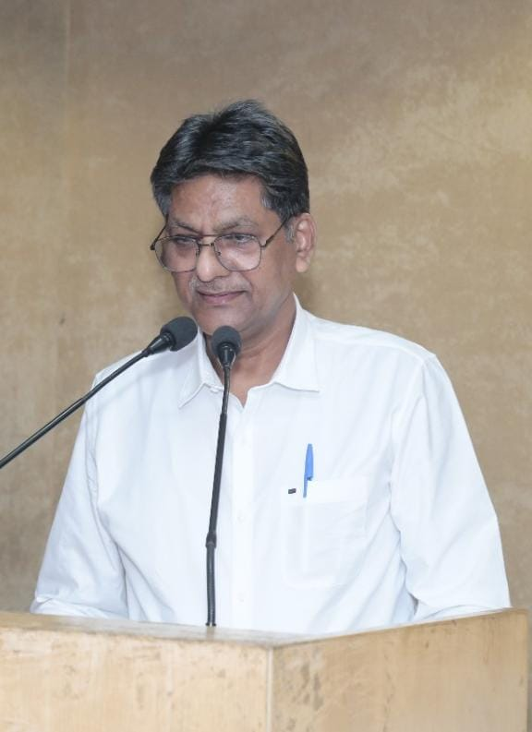
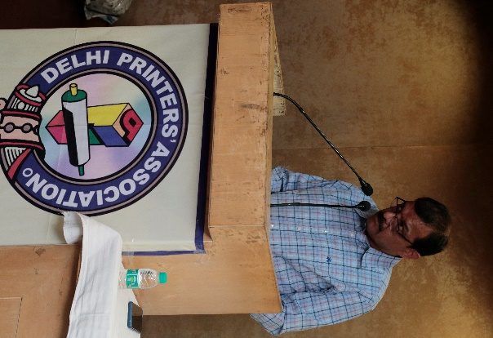
Greeting the members the Hon. General Secretary Mr. Atul Goel presented his Annual Report for the outgoing year. He condoled the deaths of members during the past year by reading out their names and at his request the audience stood up in silence for two minutes to pray for the eternal bliss of the departed souls. Then he read out association’s main activities given in the printed Report as well as the Minutes of the AGMs of 2019-2020 and 2020-2021 held on 12th November 2021. The Treasurer Mr. Prakash Dass presented the Statement of Annual Accounts for the preceding 2020-2021 period. When adoption of the Annual Report, Statement of Accounts and Minutes was sought, the members gave their procedural formal approval to all of them.
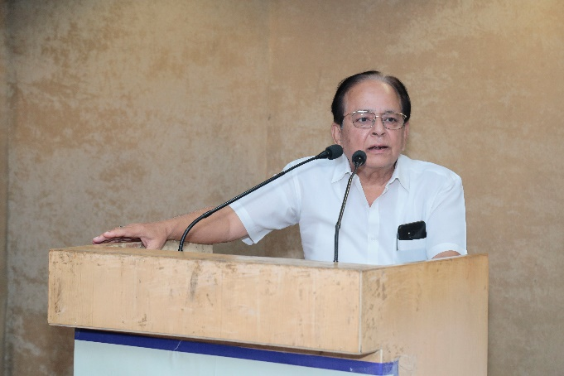
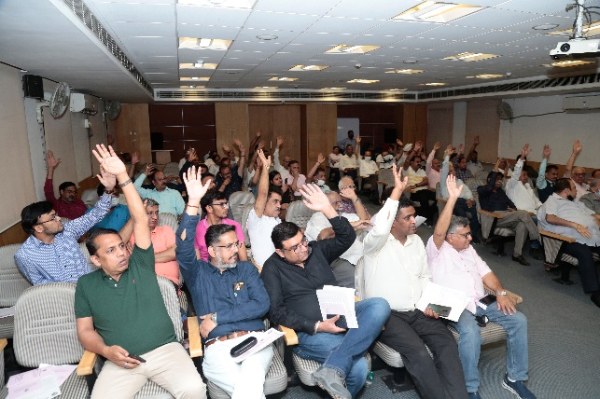
Taking up the last item of agenda "Deteriorating Condition of DPA’s Printers Bhawan at Naraina, senior former President Mr. Vijay Mohan stated that with the concerted efforts of then President Mr. Arun Berry the land of Printers Bhawan was converted into freehold in 2010 and after a thorough renovation of the building the ground floor and subsequently the basement areas were leased out to the Janata Co-operative Bank. However, within a short span of time a 'bargad' tree grew up fast on road along the outer boundary wall of Printers Bhawan and has since been posing a grave danger to neighbouring buildings also. Its roots have spread ominously and have already damaged the foundation of the Bhawan resulting in a number of cracks in the main structure. Mr. Vijay Mohan informed that for quite some time this serious situation has regularly been discussed during Executive Committee meetings and various remedial measures and other options suggested by architects and contractors have been considered in depth. The association does not have enough funds to either reconstruct the building or to sell the Bhawan as it is and buy a new property of the existing size elsewhere. He explained that like him some other senior former Presidents had also sought different alternatives from builders but every one of them has given only one option which turns out that the builder will demolish the present structure and on the same land construct a new building with modern facilities. But while he shall give the basement, stilt parking, ground, first and second floors to DPA, he will keep the third floor with terrace rights for his own use. The members agreed that as per current market trend the builders' offer is the only workable option for DPA also and they gave their unanimous decision in its favour. Thus it was finally adopted that DPA will sign a necessary legal document with a known and reliable builder who will construct a strong building, as per approved map or plan, on DPA's land.
After completion of the agenda of AGM some members raised the burning issue of skyrocketing hikes in rates of almost all inputs and raw materials of printing and packaging trade. Mr. Pradeep Babbar of Babbar Offset Printing Press enquired whether DPA can provide relief to members in this serious matter. Mr. Vijay Mohan stated that the unprecedented increase in prices of raw materials is prevailing throughout the country and so this grave issue was also discussed at the March GC Meeting of All India Federation of
Master Printers. The GC members were of the view that in the present scenario printers cannot survive unless they also hike their printing and packaging rates proportionately. Former President of DPA Mr. Mukesh Kaushik, Vice President Mr. Deepak Bhatia and other functionaries joined the issue by stating that printers must sincerely work out their costing and then increase their rates to the tune of 40% or so. Cut-throat competition among printers should stop and they must learn to say 'No' to their customers who threaten to go to some other printer.
Raising the complex issue of default in payment by some clients after a printer has executed their jobs, Mr. Daman Gandhi of Suryansh Enterprises wanted DPA's help to affected members in realisation of due payments. Mr. Vijay Mohan pointed out that over 10-12 years back DPA had advised all members to print at the bottom of their invoices a condition stating "In case of any dispute about settlement of this invoice Delhi Printers' Association's mediation will be acceptable to both the parties." He said only then DPA can mediate; 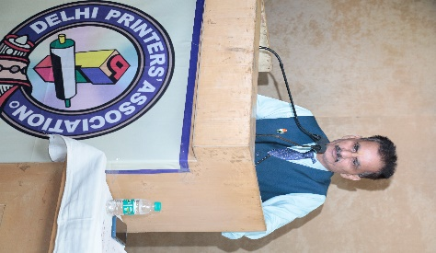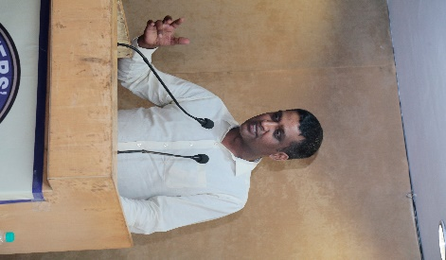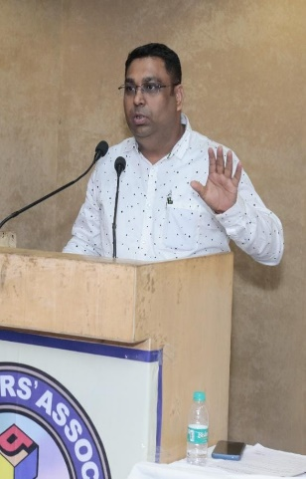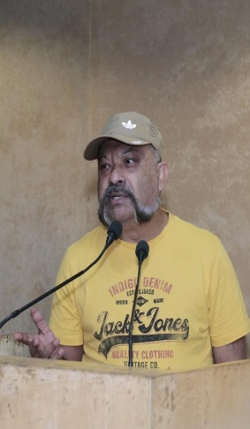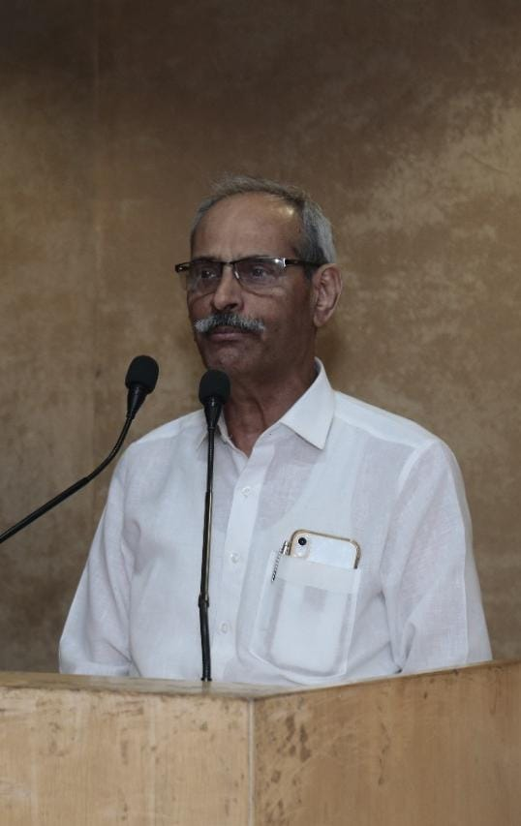
otherwise the association has no role to play. He told that to avoid such a situation member should demand the association's interference by printing the said condition on their invoices. Mr. Prabir Mukherjee of Multi Colour Services desired that the association should fix a set of minimum rates for different printing processes and request the members not to execute any job below those rates. He also pointed out that the MSME Ministry has installed an online service which can be used for lodging complaints about non-payment of dues. Mr. M. N. Pandey, Executive Member, also addressed the members and insisted that printers must do proper homework on costing first and only then quote their rates to the party.
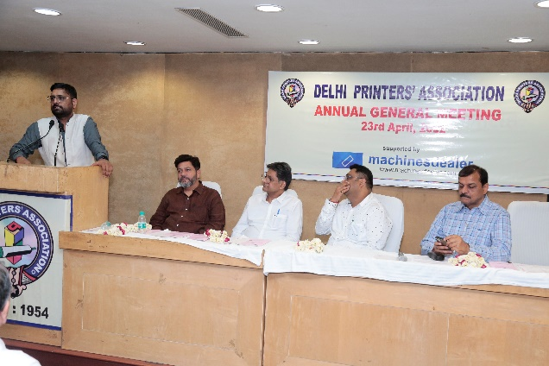
CA Mr. Mohit Golchha, an honourable Guest and a well wisher of the Association members, also asked the members to draw a bigger line instead of worrying about the increasing rates of paper and other raw materials. He was also of the opinion that printers should try to increase their printing rates as per their costing instead of asking the suppliers not to hike rates of their raw materials. How can one force someone not to increase the rates of their product if it is unavoidable. Members applauded his point of view.
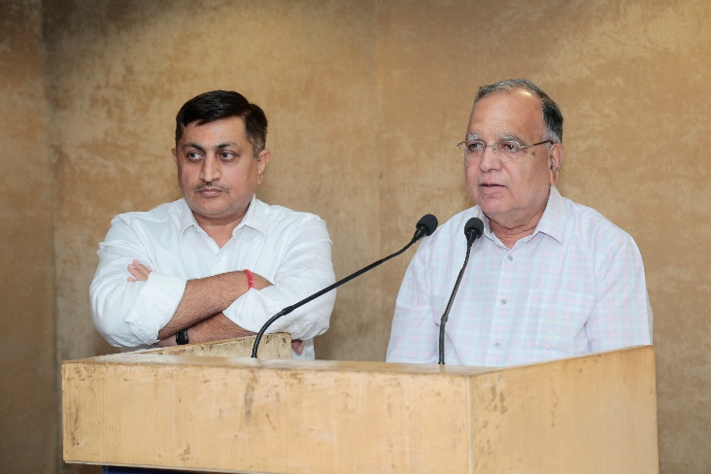
Returning Officer Mr. Raj Kumar Arya and Co-Returning Officer Mr. Mukesh Kaushik for DPA's annual election for 2022-2023 announced that due procedure of calling nominations from intending candidates for election to coveted posts of Office Bearers and Executive Committee Members was duly followed. Since the number of nominations received for Office Bearers and E C. Members was equal to the number of posts to be won there was no candidate left to contest and so there was no need for holding of the election. He read out names of the unanimously elected new team for 2022-2023 and invited them to assemble at the stage for a group photograph. Amid loud clapping members of the new team were individually welcomed and congratulated with garlands by the outgoing Office Bearers and senior former Presidents.
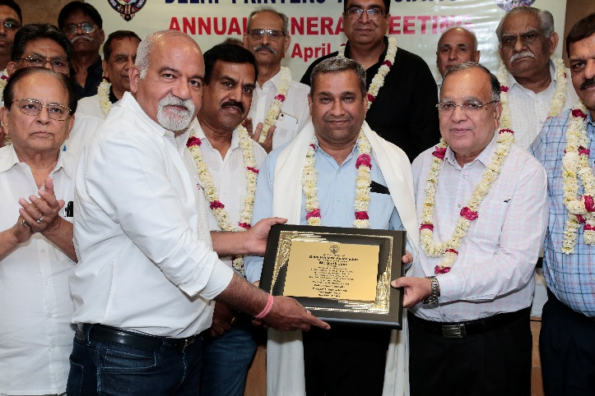
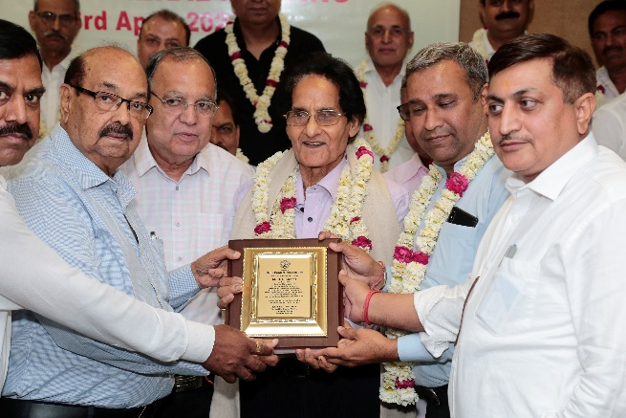
The outgoing President for 2021-2022 Mr. Sunil Jain was honoured with a memento and a shawl in recognition of his exemplary stewardship, farsighted vision and for raising the benchmark of remarkable achievements for the printing fraternity. Calling him as a guardian of the welfare of DPA, former Presidents, led by Mr. Vijay Mohan, felicitated the incumbent Executive Secretary of DPA Mr. H. L. Khanna with a memento and a shawl for his long-lasting selfless devotion to duty, commitment and professionalism. He was requested to continue with his experiential dedication to the association in future as well. With folded hands Mr. Khanna thanked everyone for their gracious gesture. Further, last year, office assistant Mr. Durgesh Kumar had taken voluntary pre-mature retirement from service due to some personal problems. In order to recognise 35 years of his hard work and loyalty to DPA a memento was to be presented to him also but as he could not come to the meeting due to unavoidable circumstances, it was decided to graciously present him the momento at his home personally.
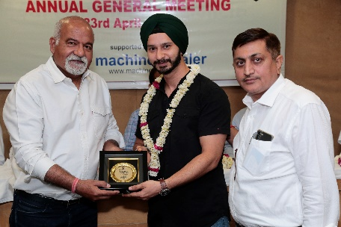
Later on, Mr. Harpreet Singh Kohli of Machinesdealer was invited to the stage and was handed over a memento in gratitude of his sponsorship of the event. He praised the role of DPA and hoped that his firm will gain with mutual support.
The meeting ended with a vote of thanks to the chair. The event concluded with refreshments.

